**Independent University, Bangladesh**



**Project Draft Report**

**Course Title:** Database Management

**Course Code:** CSE 303

**Section:** 04

**Prepared for:** Ms. Sadita Ahmed

**Prepared By:**

Mohammad Arshad Hossain Ratul (1930319)

Tunisha Yanoor Bristy (1930639)

Refat Ahmed Bhuiyan (1930053)

Nahin Islam (1930577)

Tasnia Tabassum Oishee (1910040)

Sadia Islam Semi (1930127)

Department of Computer Science & Engineering

School of Engineering, Technology & Science

Independent University, Bangladesh

STUDENT ENROLLMENT AND REVENUE ANALYSIS

Table of Contents

Chapter 1 5

Introduction 5

a: Background of the Organization: 5

B: Background of the Project: 5

C: Objectives of the Project: 5

D: Scope of the project: 6

Chapter 2 7

Requirement Analysis 7

A: Rich Picture of existing business system 7

B: existing Six system elements 7

C: Business Process Diagram (AS-is) 14

CHAPTER 3 17

Logical System Design 17

a: bUSINESS RULES 17

B: Entity Relation Diagram (ERD) 18

C: Relational schema 19

D: Normalization 19

E: Data Dictionary 21

Figure 1: Rich picture (AS-IS) 7

Figure 2: Generate revenue table and chart for each school 14

Figure 3: Prepare Tally Sheet 14

Figure 4: Prepare classroom requirement summary as per class size 15

Figure 5: Analysis of unused resources for each school 15

Figure 6: Generate Percentage Change in Revenue for each School 15

Figure 7: Store the number of section offered in SETS department 16

Figure 8: ANALYSIS OF NUMBER OF SECTIONS FOR EACH SEMESTER 16

Figure 9: Entity Relation Diagram 18

Figure 10: Relational Schema 19

Figure 11: Normalization 20

# Chapter 1

## Introduction

### a: Background of the Organization:

Independent University, Bangladesh(IUB) is one of the first private universities of Bangladesh. It was established in 1993. Currently around 8,423 students are enrolled in IUB. Moreover, IUB currently has 13,745 alumni and 401 faculty members who are contributing to outstanding research in a variety of fields. IUB conducts its academics through various Schools. Currently, IUB has 5 Schools:

1. School of Entrepreneurship and Business.
2. School of Engineering, Technology and Sciences.
3. School of Environment and Life Sciences.
4. School of Liberal Arts and Social Sciences.
5. School of Pharmacy and Public Health.

Under each School, there are several departments. Currently, IUB has a total of 12 departments. As per the world university rankings of Times Higher Education (THE) IUB stands within 400th universities globally in terms of various aspects of impact analysis. Moreover, IUB provides various types of scholarships to encourage the students in academics. With the help of well-equipped laboratories as well as an enormous library, students and researchers get to invest their knowledge efficiently.

### B: Background of the Project:

This project is used to analyze the enrollment process of a specific organization.This project focuses on decreasing the manual labor for tasks. Moreover, various kinds of users for an organization like IUB can use the software to view information. Both the enrollment data and revenue information are stored in the database. In addition, detailed data of all the courses for each department is added including credit hour, course ID, currently enrolled students, etc. The data stored can be used to generate various charts and tables in order to view the information required. In the enrollment process we can see the information of course’s course name, course ID, course section, maximum capacity, enrolled capacity, class time and days. There is information available such as faculty name, faculty ID, classroom number, school name and others. The project works by taking an input from the user through which it can generate charts/tables that the user wants to view.

### C: Objectives of the Project:

The objective of our project is to perform some of the significant tasks that need to be done repeatedly. With the help of this project, the time consuming tasks that are done manually are done within a short span of time. The basic functions of this project are:

* Store the enrollment information of students of each Semester for each School and Department.
* Analyze the revenue of each School for selected Semesters as well to view the percentage change in revenue for each School from a specific semester to another.
* Generate the classroom requirement for each day for a specific number of slots.
* Analyze the resources of IUB by observing the amount of unused resources.

With the help of this software, the human interference in these vital tasks are reduced and hence, the results are more precise as it has less chance of errors. Moreover, by automating the tasks, the time can be utilized elsewhere. In addition, data can be accessed easily.

Although building a software like this might seem expensive but on a larger scale considering doing the same tasks manually, it is more efficient and less costly to go for automated processes.

### D: Scope of the project:

This project is giving out solutions to enrollment issues and revenue changes. This project is helping students, faculty, department managers and others to use this web app for data:

* storing
* editing
* adding
* updating
* viewing

We designed possible users for the web-based system for the users and imagined how they would use it, as well as the information and data they would require.

We will create customized user interfaces and login capabilities for all participants who will be users of this system, because problems might develop at any stage in any business process.

We use this system for data storage, so obtaining relevant files, tabular data, formats, and reports is really simple, and we can interact with the data in real time.

We also build user interfaces that allow all users to quickly access data and generate and download reports.

# Chapter 2

## Requirement Analysis

### A: Rich Picture of existing business system

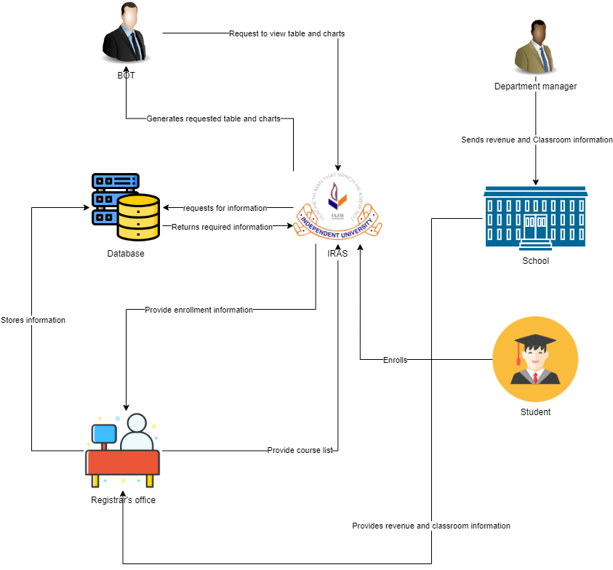

Figure : Rich picture (AS-IS)

### B: existing Six system elements

|  |  |  |  |  |  |  |
| --- | --- | --- | --- | --- | --- | --- |
| **Process** | **System Roles** | | | | | |
| **Human** | **Non-Comp**  **Hardware** | **Computing**  **Hardware** | **Software** | **Database** | **Network & communication** |
| **Generate revenue table and chart for each School** | **Board of Trustees:**  1.Login to iras  2.Request to view revenue table and chart.  3. Select a school to generate revenue  4. Select a semester for which they want to view the revenue. | **Paper:** Used to print the chart and table | **Computer:**  1.Used to login to iras  2. Board of trustees use computers to view table and charts from the  school he wants to view it for  Printer:  1. To print out the chart and data from the table | **Iras:**  1. Board of trustees use iras to download the tables and chart in excel file  Microsoft Excel:  1. Excel Sheet is used by  Board of trustees to read the table data | **Database:**  1. IRAS uses a Database server to generate  the table and chart. | **Internet:**  1. The Internet is used to Communicate with IRAS to browse the software/ webpage where the board of trustees can generate revenue. |
| **Prepare tally sheets** | **Registrar’s Office:**  1.Login to iras  2.Download enrollment information provided by the system(iras)  3.Make a tally sheet from the downloaded enrollment information.  4.Input the enrollment information for each School separately  5. Store the data into the database | **Paper:** Used to print the tally sheets in order to store the hardcopy | **Computer:**  1.Used to login to iRAS  2. Used to download the enrollment file  3.Used to make another excel file  4.Used to upload the excel file for each department into the system which is the tally sheet  Printer: Prints the hardcopy of the tally sheet | **Microsoft Excel:** Used to make the tally sheet  **iRAS:** used to download the enrollment information. | **Database:** used to store all the tally sheets for every semester | **Internet:** 1.Used to login to iRAS  2.Used to upload the tally sheet into database |
| **Prepare classroom requirement summary as per class size** | **Department manager:**  1.Count the number of classrooms.  2. Count the number of seats available.  3. Sends data to the respective school  **School:**  1. Receives the data from each department manager.  2. Merge the data from all the departments.  3. Calculates the number of sections required and per availability .  4. Assign faculty members for each section.  5. Send them to the Registrar's office.  **Registrar's office:**  1. Receives the merge list of each school.  2. Make a tally sheet.  3. Store it in the database. | **Pen and paper:**  1. Used for keeping the hardcopy of manually counted data. | **Computer:**  1. Used for making a spreadsheet of the data.  2. Email the spreadsheet to the Registrar's office.  Printer:  1. To keep a hard copy if any data is misplaced. | **Excel:**  1. Used to make the soft copy of the data  2. Used to make the tally sheet.  **E-mail:**  To send an email to the Registrar's office. | **Personal computer:**  To store the spreadsheet. | **Internet:**  1. To send email. |
| **Analysis of unused resources for each School** | **School:**  1.  Provides a detailed list of resources unused.  Registrar’s office :  Receives the information of unused resources from each School  Makes an excel sheet to store the information for each School  Store the sheet into the database  **Board of Trustees:**  1.Login to iras  2. Provide the number of students to navigate which sections has less than that number of students enrolled for each School  3. View the information as well as the total number of sections of that has less than that number of students enrolled for each School. | **Paper:**  1. Used to print the analysis for keeping hardcopy | **Computer:**  1. Used to give excel files to the register office.  2.Used to login to iras.  3. Used for input all unused resources information.  **Printer:**  1.To print the analysis. | **Excel:**  1.Excel Sheet is used by  registrar office so that it can input data in database  **iRAS:**  1.Used to store the information provided by the registrar's office.  2. Used to give input of the number of students. | **Database:**  1.Stores information of unused resources.  2.Generats the analysis as per the input of the Board of Trustees. | **Internet:**  1.Used for  login in iRas.  2.Used to  upload the information into the database.  3.Used to access database. |
| **Generate percentage change in revenue for each School** | **Board of Trustees:**  1. Login to RAS  2. Requests to generate the percentage change in revenue for the desired School  3. Print the generated chart if needed. | **Paper:** Used to print the generated chart to keep it as a hardcopy. | **Computer:**  1.Used to login to iRAS  2. Used to download the generated report for a specific School  **Printer:** Used to print the report on a paper. | **iRAS:**  1. Used to login  2.Used to generate the percentage change in revenue. | **Database:**  Contains the revenue information for each semester | **Internet:** Used to login to iRAS and download the report |
| **Store the number of sections offered in SETS department** | **Department Manager:**  1. Logs into iRAS  2. Set the number of sections for each course  3. Send the data to respective School  **School:**  1. Receives the number of sections needed for each course  2. Sends it to Registrar’s office  **Registrar’s office:**  1. Receives the information regarding each course  Makes a spreadsheet  2. Sends to database to store information. | **Paper:**  1.It is used to keep the hardcopy of the number of sections offered in each course in the SETS department. | **Computer:**  1.It is used to log in to iRAS  2.It is used to make a spreadsheet  3.It is used to make sections and upload it into the database. | **iRAS:**  1.It is used to log in  2.It is used to upload/update information  3.The number of sections offered are viewed here.  **Microsoft Excel:**  1.It is used to make a spreadsheet.  **Email:**  1.It is used to sent the information. | **Database:**  1.Stores the information  2.Sends the information to iRAS. | **Internet:**  1.It is used to login to iRAS  2.It is used to upload information in iRAS or use the webpage  3.It is used to upload the information in database |
| **Analysis of number of sections for each semester** | **Board of Trustees:**  1. Login in IRAS  2. Request for the list of sections for a particular course.  3. Requests “n” numbers and shows the sections which have students less than “n”.  **Registrar’s office:**  1. Downloads the enrollment data from the iras.  2. Stores the enrollment data in the database. | **Paper:**  1.Used to print hardcopy of the analysis | **Computer:**  1.Used to login to iRAS  2.  Board of trustees use computers to see a list of section that has less than the number he gave he input  3.  Register office use computer to provide the required information  **Printer:**  1.Used to print out the report if need be. | **Iras:**  1.Registrar’s office use iras to download the  enrollment data from the iras  **Microsoft Excel:**  1.View the downloaded  Excel Sheet | **Database:**  1.Used to fetch data. | **Internet:**  1.Used to login to iRAS  2.To access iras and databases. |

### C: Business Process Diagram (AS-is)

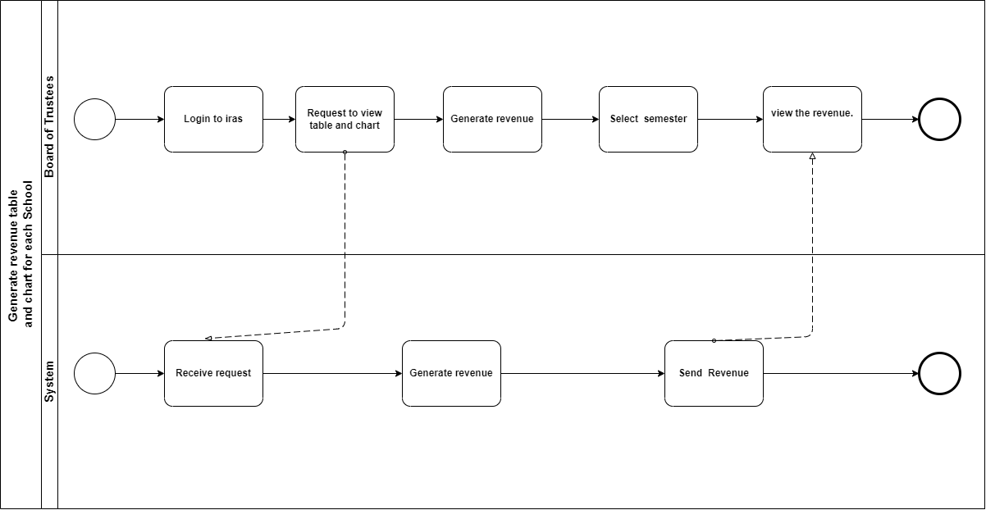

Figure : Generate revenue table and chart for each school

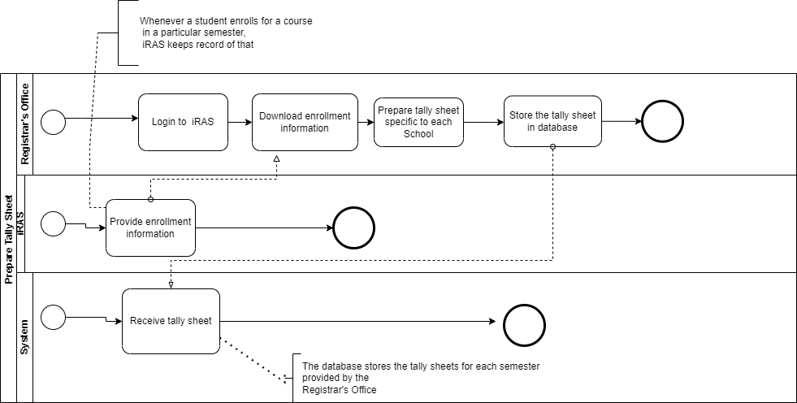

Figure : Prepare Tally Sheet

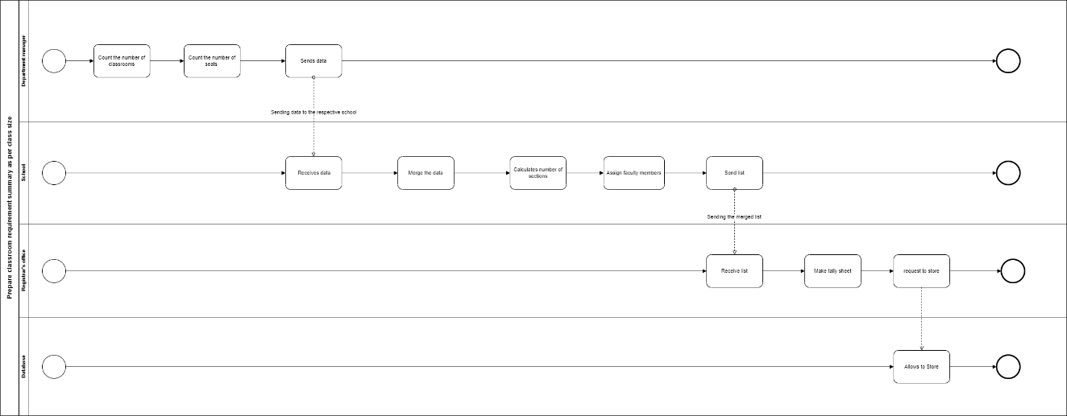

Figure : Prepare classroom requirement summary as per class size

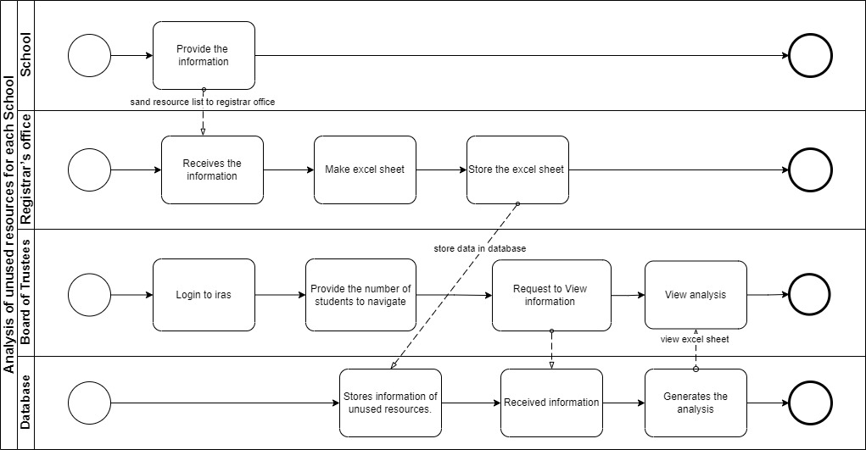

Figure : Analysis of unused resources for each school

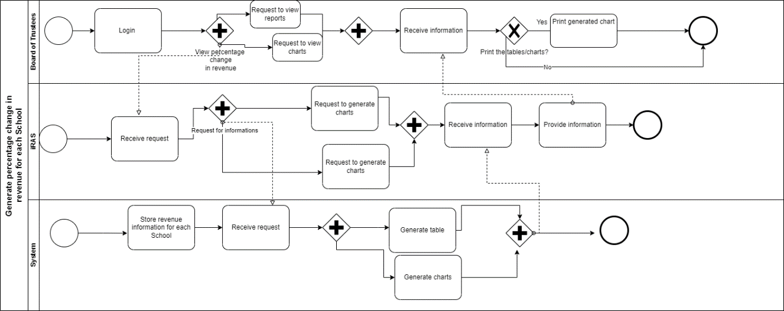

Figure : Generate Percentage Change in Revenue for each School

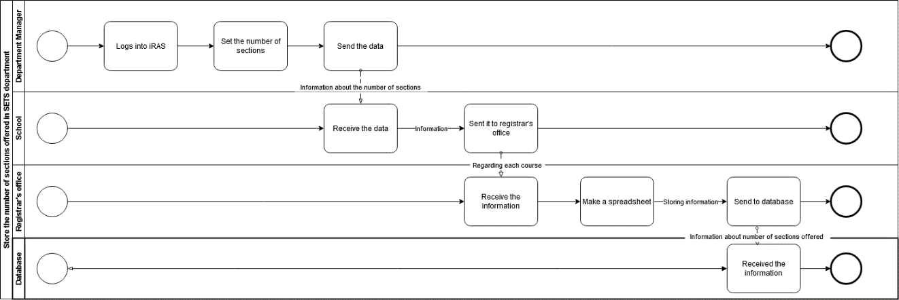

Figure : Store the number of section offered in SETS department

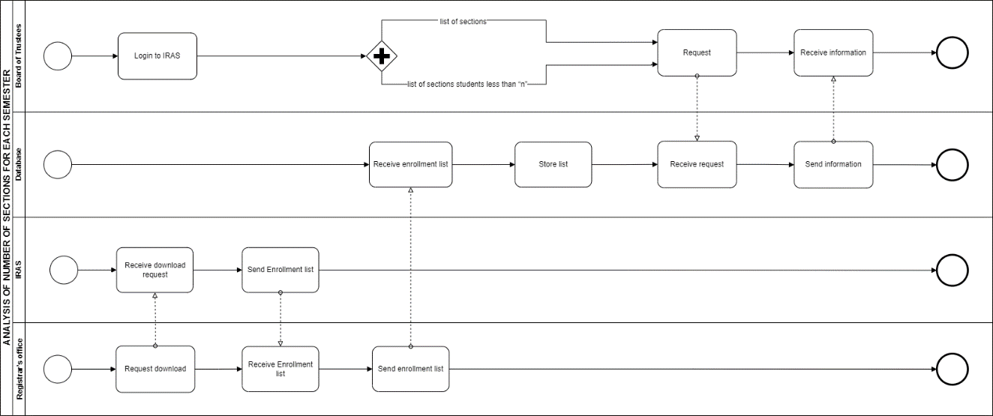

Figure : ANALYSIS OF NUMBER OF SECTIONS FOR EACH SEMESTER

# CHAPTER 3

## Logical System Design

### a: bUSINESS RULES

1. The academics of IUB consists of School and Department.
2. Each School has a unique identifier and name.
3. Each School consists of several Departments. A department must belong to a School and a School must have at least one or more departments.
4. Departments have departmentID to uniquely identify each department as well as department name.
5. Departments offer courses. A department must offer one or many courses. At least one course must belong to one department.
6. Courses have CourseID, number of credits, course name, number of sections, departmentID, classroomNumber, prerequisite.
7. A course must be taught by one Faculty. A faculty may take one or more courses.
8. One course must have at least one or more sections.
9. Faculty has facultyID, faculty name, courseID.
10. A section must have one Faculty assigned to a specific classroom. A Faculty can take one or more sections.
11. Courses are offered every semester. Semesters have a session and year.
12. Semesters can be identified using both session and year.
13. Sections have section number, courseID, semester session and year, classroomNumber, facultyID, maximum_capacity, enrolled_capacity, class_time which has the starting and ending time of a class as well as the number of days, blockedStatus.
14. A faculty can hand over a course of a specific section to another faculty for a particular semester.
15. Classrooms are assigned to a specific section based on the enrollment capacity.
16. Classrooms are used in slots. For IUB, it is 6 slots or 7 slots for each day.
17. A section is assigned to only one slot at a time.
18. Each course must have at least one slot per week. For some courses, it can be two slots per week.

### B: Entity Relation Diagram (ERD)

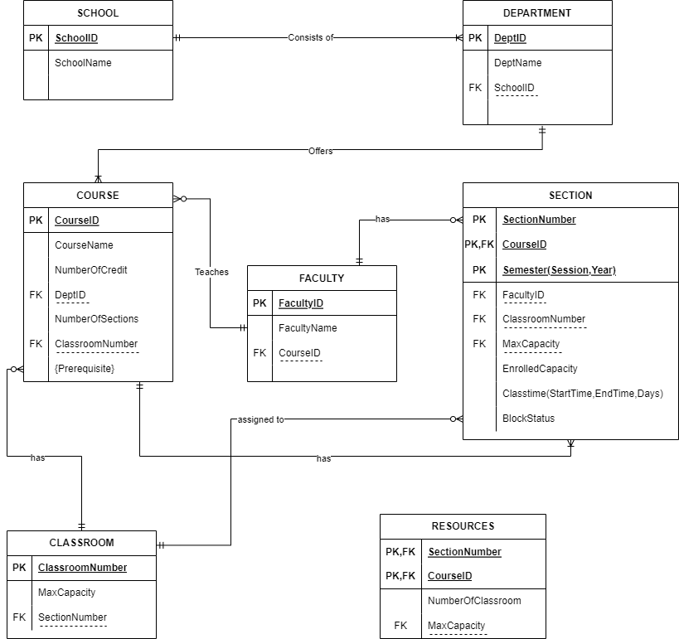

Figure : Entity Relation Diagram

### C: Relational schema

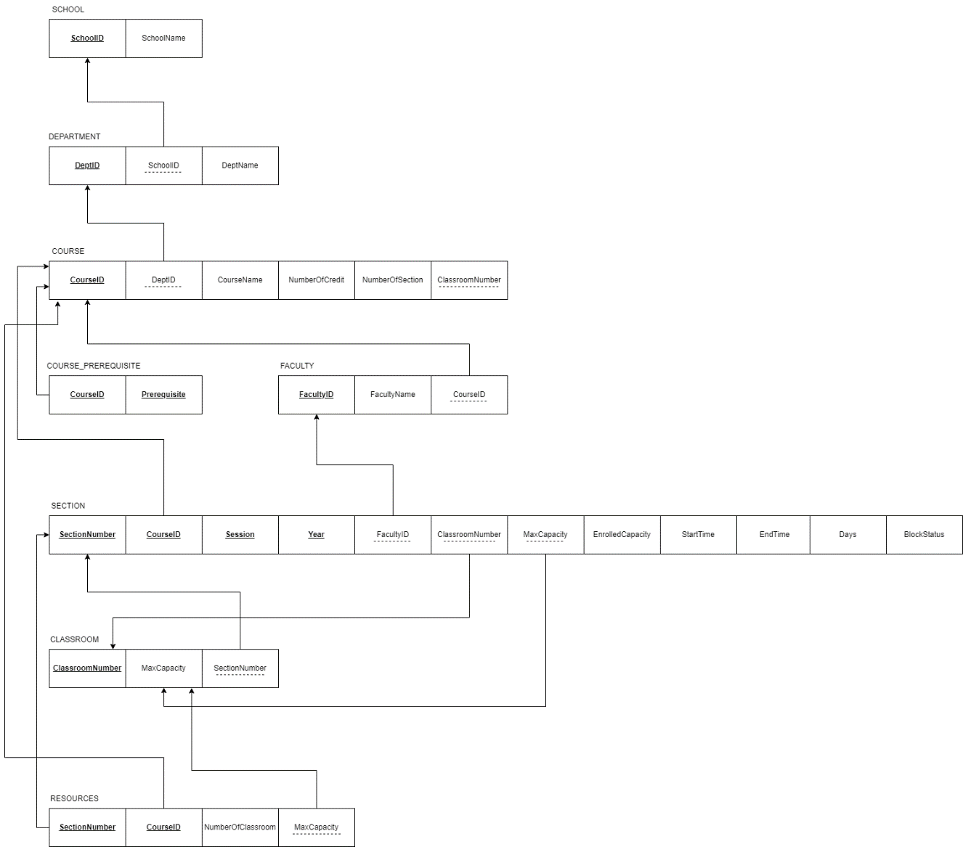

Figure : Relational Schema

### D: Normalization

DeptID DeptName, SchoolID

CourseID NumberOfCredit, CourseName

DeptID, SectionNumber, CourseID, Session, Year FacultyID, classroomNumber, MaxCapacity, EnrolledCapacity, StartTime, EndTime, Days, BlockStatus

ClassroomNumber MaxCapacity, SectionNumber

SchoolID SchoolName

FacultyID FacultyName

Prerequisite CourseID

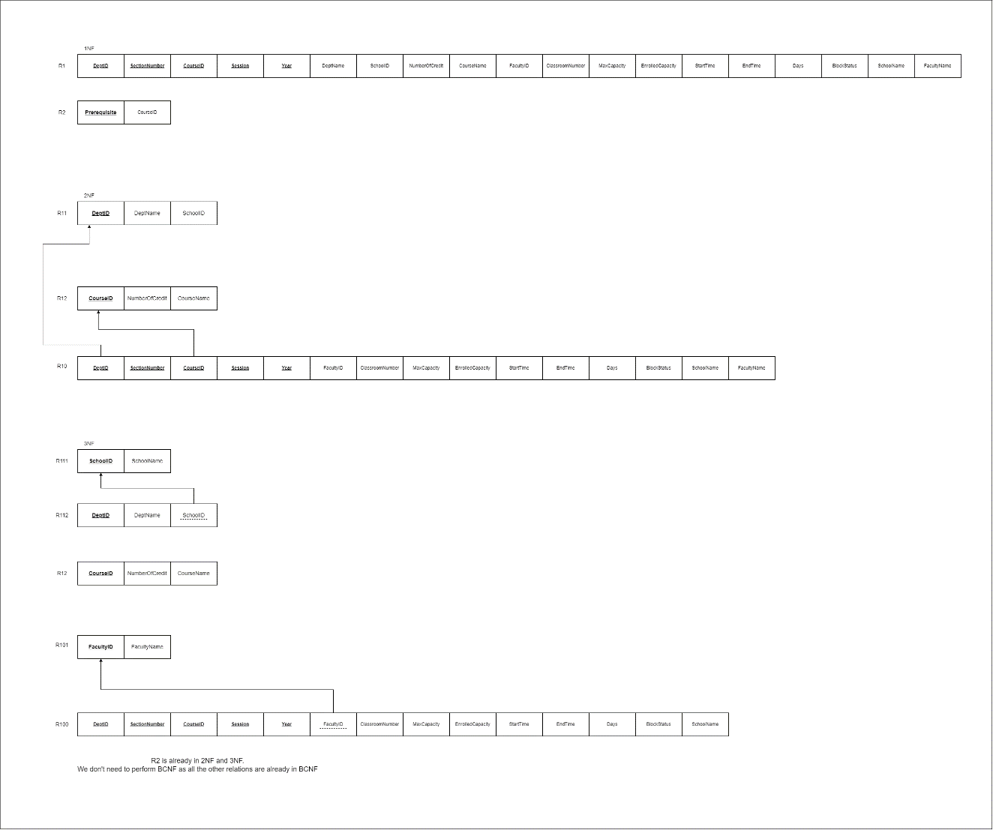

Figure : Normalization

### E: Data Dictionary

|  |  |  |  |
| --- | --- | --- | --- |
| Name | type | Size | Remark |
| SchoolID | VARCHAR | 6 | This is the primary  Key of this relation. It contains the ID of the school.  Ex: SETS |
| SchoolName | VARCHAR | 30 | This is the name of the school  Ex: School of engineering and technology. |

SCHOOL:

DEPARTMENT:

|  |  |  |  |
| --- | --- | --- | --- |
| NAME | TYPE | SIZE | REMARK |
| DeptID | VARCHAR | 5 | This is the primary key  Of this relation which contains the ID of dept  Ex: CSE, EEE |
| DeptName | VARCHAR | 30 | This is the name of dept.  Ex: Computer Science and Engineering. |
| SchoolID | VARCHAR | 6 | This is the foreign key from SCHOOL table. |

Course:

|  |  |  |  |
| --- | --- | --- | --- |
| NAME | TYPE | SIZE | REMARK |
| CourseID | VARCHAR | 10 | This is the primary key  Of this relation which contains the ID of course.  Ex: CSE303 |
| CourseName | VARCHAR | 30 | This is the name of course.  Ex: Database management system |
| NumberOfCredits | NUMBER | 1 | It contains the number of credits for a course.  Ex: 3 credits for DBMS |
| DeptID | VARCHAR | 10 | This is the foreign key from Department table. |
| NumberOfSections | NUMBER | 3 | It contains number of sections.  Ex:4 Section in |
| ClassroomNumber | NUMBER | 6 | It contains the number of classrooms  Ex: 5 |
| Prerequisite | VARCHAR | 6 | It contains number of prerequisite courses.  Ex: 203 prerequisite 201 |

FACULTY:

|  |  |  |  |
| --- | --- | --- | --- |
| NAME | TYPE | SIZE | REMARK |
| FacultyID | VARCHAR | 4 | This is the primary key of the relation. It contains the Id of the faculty.  Ex:4242 |
| FacultyName | VARCHAR | 30 | It contains the name of the faculty.  EX: Ms. Sadita Ahmed |
| CourseID | VARCHAR | 7 | Course Id is the foreign  Key from COURSE table. |

SECTIONS:

|  |  |  |  |
| --- | --- | --- | --- |
| NAME | Type | Size | Remark |
| SectionNumber | NUMBER | 10 | This is the primary key of this relation.  It contains the total number of sections.  Ex: CSE 303 HAS 4 SECTIONS |
| CourseID | NUMBER | 10 | This is the primary key as well as a foreign key from COURSE table. |
| Semester | VARCHAR | 15 | This is a primary key of this relation. It contains the session and year of the semester.  Ex: Summer,2022 |
| FacultyID | NUMBER | 10 | Faculty ID is the foreign key from FACULTY table. |
| ClassroomNumber | NUMBER | 10 | Classroom number is a foreign key from CLASSROOM table. |
| MaxCapacity | NUMBER | 3 | This is a foreign key from CLASSROOM |
| EnrolledCapacity | NUMBER | 2 | It contains the number of enrolled capacity.  Ex: CSE303 has 30 seats |
| StartTime | VARCHAR | 6 | It contains the time and date of a course.  Ex:8AM |
| BlockStatus | bool |  | It will check section block or not  Ex: section is block or not. |
| EndTime | VARCHAR | 6 | It contains the time and date of a course.  Ex: 11am |
| Days | VARCHAR | 2 | It contains the time and date of a course.  Ex: MW |

CLASSROOM:

|  |  |  |  |
| --- | --- | --- | --- |
| Name | Type | Size | Remark |
| ClassroomNumber | VARCHAR | 6 | This is the primary key of this relation it contains the classroomNumber.  Ex:BC5004 |
| MaxCapacity | NUMBER | 6 | It contains the maximm capacity of the class.  Ex: CSE303(30) |
| SectionNumber | NUMBER | 6 | This is a foreign key from SECTION. |

RESOURCES:

|  |  |  |  |
| --- | --- | --- | --- |
| NAME | Type | Size | Remark |
| SectionNumber | NUMBER | 7 | This is a foreign key from section table |
| CourseID | NUMBER | 7 | This is a foreign key from course table |
| NumberOfClassroom | NUMBER | 7 | This contains total number of classroom |
| MaxCapacity | NUMBER | 7 | This is a foreign key from Classroom table |